**2024CUPT竞赛题目**

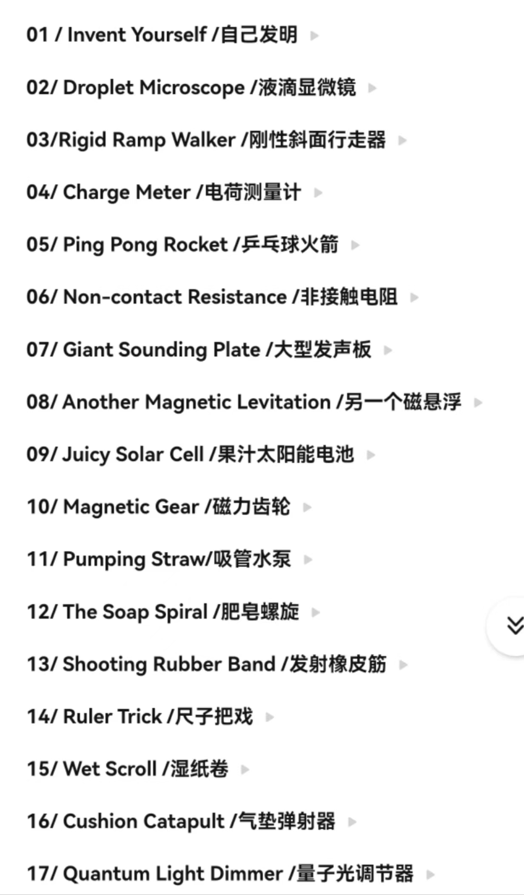

## 01 / Invent Yourself /自己发明

Take a box (e.g. a matchbox), filled with identical objects (e.g.matches, balls, …). Find a method to determine the number of objects in the box solely by the sound produced while shaking the box. How does the accuracy depend on the properties of the objects, the box, and the packing density?

考虑一个装满相同物体（如火柴、球）的盒子（如火柴盒），找到一种方法来仅通过晃动盒子时产生的声音来确定盒子中物体的数量。这种方法的准确性如何取决于物体的性质、盒子的性质和装填密度？

## 02/ Droplet Microscope /液滴显微镜

By looking through a single water droplet placed on a glass surface, one can observe that the droplet acts as an imaging system. Investigate the magnification and resolution of such a lens.

透过一滴放置在玻璃表面的水滴观察，可以发现水滴能充当一种成像系统。研究这种透镜的放大率和分辨率。

## 03/Rigid Ramp Walker /刚性斜面行走器

Construct a rigid ramp walker with four legs (e.g. in the form of a ladder). The construction may begin to ‘walk’ down a rough ramp. Investigate how the geometry of the walker and relevant parameters affect its terminal velocity of walking.

搭建一个有四条腿的刚性斜面行走器（如梯子的形式），此结构可以在粗糙的斜面上向下“行走”。研究行走器的几何特征及相关参数如何影响其行走的最终速度。

## 04/ Charge Meter /电荷测量计

A lightweight ball is suspended from a thread in the area between two charged plates. If the ball is also charged it will be deflected to one side at a certain angle. What is the accuracy of such a device for measuring the amount of charge on the ball? Optimise your device to measure the smallest possible charge on the ball.

一个轻质小球通过一根线被悬挂在两个带电板之间。如果球也带电，它会以一个特定的角度被偏转到一侧。这种测量小球带电量的装置的精度是多少？优化你的装置用于测量球上可能的最小电荷。

## 05/ Ping Pong Rocket /乒乓球火箭

A ping pong ball is placed in a container of water. When the container is dropped, the ping pong ball will get launched to a great height. What maximum height can you reach with up to 2 liters of water?

一个乒乓球放置在装水的容器中，当容器被释放时，乒乓球会发射到一个很高的高度。使用2升水最高能达到多少高度？

## 06/ Non-contact Resistance /非接触电阻

The responses of a LRC circuit driven by an AC source can be changed by inserting either a non-magnetic metal rod or a ferromagnetic rod into the inductor coil. How can we obtain the magnetic and electric properties of the inserted rod from the circuit’s responses?

交流电源驱动的LRC电路响应可通过在电感线圈中插入非磁性金属杆或铁磁杆来改变。如何从电路的响应中得到插入杆的电磁特性？

## 07/ Giant Sounding Plate /大型发声板

When a large, thin and flexible plate (e.g. plastic, metal or plexiglass) is bent, it may produce a loud and unusual howling sound. Explain and investigate this phenomenon.

一个大的、薄的、柔韧的板（如塑料板、金属板或有机玻璃）被弯曲时，会发出响亮且不同寻常的呼啸声。解释并研究此现象。

## 08/ Another Magnetic Levitation /另一个磁悬浮

Place a large disk-shaped magnet on a non-magnetic conductive plate. When a smaller magnet is moved under the plate, the magnet on top may levitate under certain conditions. Investigate the levitation and the possible motion of the magnet on top.

将一个大的圆盘状磁铁放在非磁性的导电板上。当一个较小的磁铁在板的下方移动时，顶部的磁铁在一定条件下可能会悬浮。研究顶部磁铁的悬浮和可能的运动

## 09/ Juicy Solar Cell /果汁太阳能电池

A functional solar cell can be created using conducting glass slides, iodine, juice (eg. blackberry) and titanium dioxide. This type of cell is called a Grätzel cell. Make such a cell and investigate the necessary parameters to obtain maximum efficiency.

一个功能性的太阳能电池可以使用导电玻璃片、碘、果汁（例如黑莓）和二氧化钛来制做。这种类型的电池被称为Grätzel电池。制作这样的电池并研究获取最大效率所需的参数。

## 10/ Magnetic Gear /磁力齿轮

Take several identical fidget spinners and attach neodymium magnets to their ends. If you place them side by side on a plane and rotate one of them, the remaining ones start to rotate only due to the magnetic field. Investigate and explain the phenomenon.

取几个相同的指尖陀螺，并将钕磁铁固定在它们的末端。如果将它们并排放置在平面上并旋转其中一个陀螺，则其余的陀螺会仅由于磁场而开始旋转。研究并解释这一现象。

## 11/ Pumping Straw/吸管水泵

A simple water pump can be made using a straw shaped into a triangle and cut open at the vertices. When such a triangle is partially immersed in water with one of its vertices and rotated around its vertical axis, water may flow up through the straw. Investigate how the geometry and other relevant parameters affect the pumping speed.

一个简单的水泵可以将一根吸管折成三角形，并在顶点处切开的方式来制作。当这样一个三角形部分浸入水中，其中一个顶点绕其三角形的竖直轴旋转时，水可能会通过吸管流向上方。研究几何形状和其他相关参数如何影响泵水的速度。

## 12/ The Soap Spiral /肥皂螺旋

Lower a compressed slinky into a soap solution, pull it out and straighten it. A soap film is formed between the turns of the slinky. If you break the integrity of the film, the front of the film will begin to move. Explain this phenomenon and investigate the movement of the front of the soap film.

将一个压缩的螺旋弹簧玩具（slinky, 俗名彩虹圈）放入肥皂溶液中，把它拿出来并拉直。弹簧的圈之间就形成了一个肥皂膜。如果你破坏了肥皂膜的完整性，肥皂膜的前端就会开始移动。解释这个现象，并研究肥皂膜前端的运动。

## 13/ Shooting Rubber Band /发射橡皮筋

A rubber band may fly a longer distance if it is non-uniformly stretched when shot, giving it spin. Optimise the distance that a rubber band with spin can reach.

如果橡皮筋在发射时被不均匀拉伸而使其旋转，它可能会飞行更远的距离。优化带有旋转的橡皮筋可以到达的距离。

## 14/ Ruler Trick /尺子把戏

Place a ruler on the edge of a table, and throw a ball at its free end. The ruler will fall. However, if you cover a part of the ruler with a piece of paper and repeat the throw, then the ruler will remain on the table while the ball will bounce off it. Explain this phenomenon, and investigate the relevant parameters.

## 将一把尺子放在桌子边缘，然后将一个球投向尺子的自由端。尺子将会落下。然而，如果你用一张纸盖住尺子的一部分并重新投掷小球，那么尺子将保留在桌子上，而球会从尺子上弹开。解释这一现象，并研究相关参数。

## 15/ Wet Scroll /湿纸卷

Gently place a piece of tracing paper on the surface of water. It rapidly curls into a scroll and then slowly uncurls. Explain and investigate this phenomenon.

将一张描图纸轻轻地放在水面上。它会迅速卷曲成一纸卷，然后慢慢展开。解释并研究这个现象。

## 16/ Cushion Catapult /气垫弹射器

Place an object on a large air cushion and drop several other objects in such a way that the first object is catapulted away. Investigate how the exit velocity depends on relevant parameters.

将物体放置在一个大的气垫上，然后丢下几个其他物体，第一个物体会被弹射出去，研究弹射速度与相关参数的关系。

## 17/ Quantum Light Dimmer /量子光调节器

If you put a flame with table salt added in front of a vapour sodium lamp, the flame casts a shadow. The shadow can become lighter, if the flame is put into a strong magnetic field. Investigate and explain the phenomenon.

如果在蒸汽钠灯前放置加入了食盐的火焰，火焰会投下阴影。如果火焰放置在一个强磁场中，阴影会变得更亮。研究并解释此现象。